

**Software Design and Architecture**

**Assignment 4**

**Submitted by**

**Amir Ali Memon (SP18-BSE-014)**

**Ali Asghar (SP18-BSE-011)**

**Submitted to: Dr. Javed Iqbal**

**Submitted on: 27th December 2020**

**Department of Computer Science**

**COMSATS University Islamabad, Pakistan**

**Department of Computer Science**

Class: BS(SE)-6A Submission Date: 27 December, 2020

Subject: Software Design and Architecture Instructor: Dr. Javed Iqbal

**Prepare Software Design Document (SDD) for the Library Management System. The system provides features of New User Registration, Book Search, Book Issue, Book Return, Update Book Details and Fine Payment?**

**Table of Content**

**Introduction** 4

**Design Methodology and Software Process Model** 4

**Data Representation** 4

**Process Flow/Representation** 8

**Design Models** 13

**Algorithm & Implementation** 21

**Appendix I** 24

# **Introduction**

This Software Design Specification (SDS) document gives a detailed description of the components of the Library Management System. Its main purpose is to specify how the requirements stated in the Software Requirements Specification (SRS) will be implemented. It gives an overall guidance to the software development team by explaining the architecture of the proposed system. It also further includes multiple design models.

The purpose of the project is to maintain the details of books and library members. The main purpose of this project is to maintain an easy circulation system between clients and the library administration, to issue books using single library card, also to search, issue, return, update and reserve any book and to maintain details about the user (fine, address, phone number).

# **Design Methodology and Software Process Model**

* 1. **Design Methodology**

For this project, we will be using the Object-Oriented approach and methodology, which will enable us to divide tasks and functions easily to make the code easier to implement, understand and debug.

* 1. **Software Process Model**

The software process methodology we are using to develop the system is based on the modified waterfall. This is because it is only possible to release all the functionality of the system at once, rather than at increments, because all the requirements of the system are completely clear, simple, and straightforward. It also provides access to previous phase of software development which will help us in if we miss something in previous phase we can add, or correct information related to previous model.

# **Data Representation**

The Library Management System contains database that consists of sixteen tables. The tables along with the data, primary keys and foreign keys of this project are described as following:

1. The **Authors table** stores all the details of the authors of the books. The author table consists of three attributes which are AuthorId, AuthorName, Active. AuthorId is the primary key for this table.
2. The **Campus Table** stores the details of the different campus of the university. It consists of two attributes which are CampusId, CampusName and Active. CampusID is the primary key in this table.
3. The **RequestDetails Table** holds information of all the requests made by users for a book. The attributes of this table are RequestDetailId, RequestedBy, CopydetailId, RequestDate, RequestDeadlineDate, Status, Priority, SequenceNo. The Primary key in this table is RequestDetailId.
4. The **IssueDetails Table** stores the details of the books issued. It will store information    like whom the book is issued to, on which date the book is issued, when the book is expected to return, the return date, details of the copy with its ID. The attributes of this table are IssueDetailsId, IssuedTo, IssuedDate, ExpectedDate, ReturnDate, CopyDetailId, IssueType, RequestDate. IssueDetailsId is the primary key in this table.
5. The **CampusItem Table** Stores the information about the different campuses for the university. Each campus has a unique campus ID. The different attributes of this table are CampusItemID, ItemID, CampusId. The CampusItemID acts as the primary key in this table.
6. The different attributes of the **Categories Table** are CategoryId, ParentId, CategoryName, Description, and Active. The primary key in this table is CategoryId.
7. The different Attributes of **Items Table** are ItemId, ItemName, Publisher, AccessNumber, ISBN, Description, Keywords, ItemEdition, ItemPrice isReference, Active, PreferenceId, MediaType.
8. The different attributes of **ItemAuthor Table** are ItemId and AuthorId.
9. **ItemCategories Table** has BookId and CategoryId as the attributes. Here BookId is the primary key.
10. The **Users Table** contains all the information of the users of the Library. The different attributes of this table are UserId, LoginName, FirstName, MiddleName, LastName, CampusID, Password, Email, Active, UsertypeId. UserId will be acting as the primary key in this table.
11. The attributes of **Usertype Table** are UserTypeId and UserTypeName. The Primary Key in this table is UserTypeId.
12. The attributes of **Mediatype Table** are MediaTypeId, MediaTypeName and Active. MediaTypeId acts as the Primary Key in this table.
13. The **Reservation Tables** hold the information of all the reservations made by users for a book in the Library. The attributes of this table are ReservationId, ItemId, userId, ReservationDate and Priority. The Primary Key in this table is ReservationId.
14. **CopyDetails Table** stores the information of the different copies of books in the Library.The different Attributes of this Table are CopyDetailsId, CampusItemId, Status, CopyPrice, Active and isReference. The Primary Key in this table is CopyDetailId.
15. The **Payment Table** contains the information of the fines to be paid by users in case of late return of issuedbooks. The attributes of this table are PaymentId, IssuDetailId, TotalAmount, AmountPaid and isPaid. The primary key in this table is PaymentId.
16. The different attributes of **Preferences Table** are PrferenceId, IssueDays and Blockdays. The primary key in this table is PreferenceId.

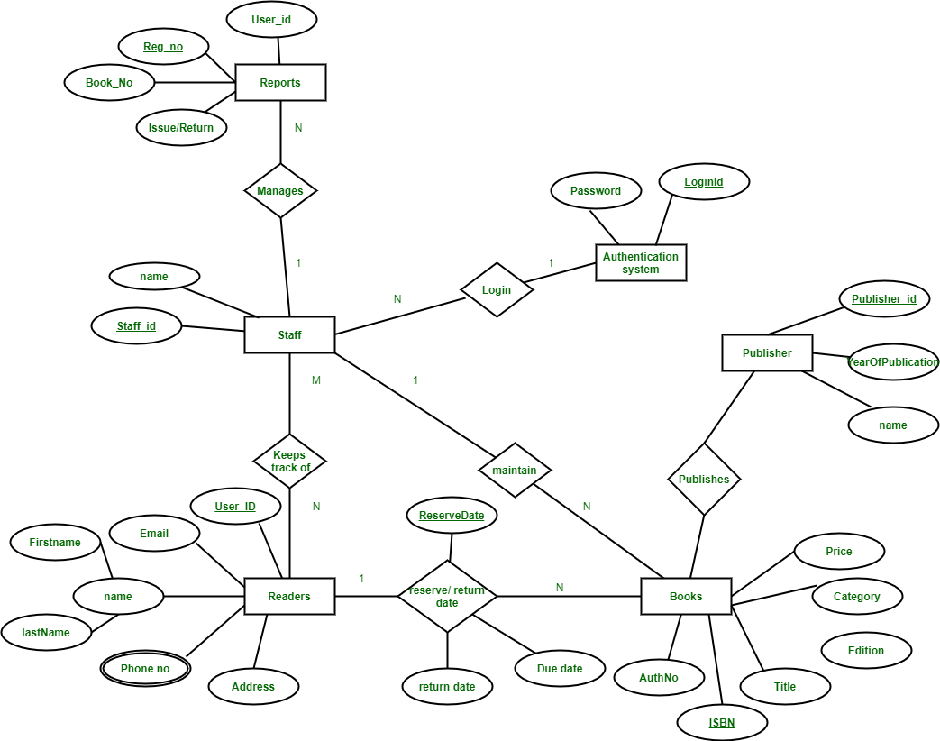

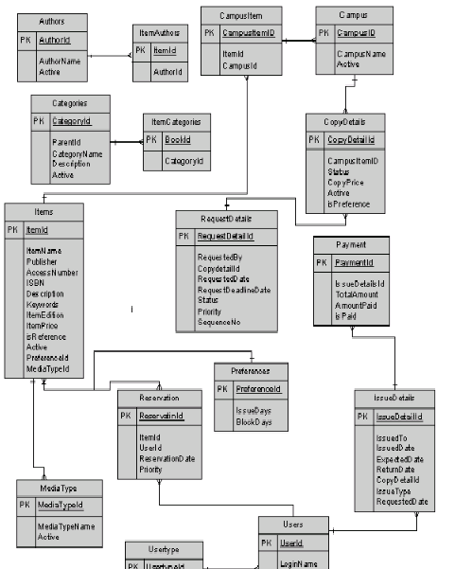

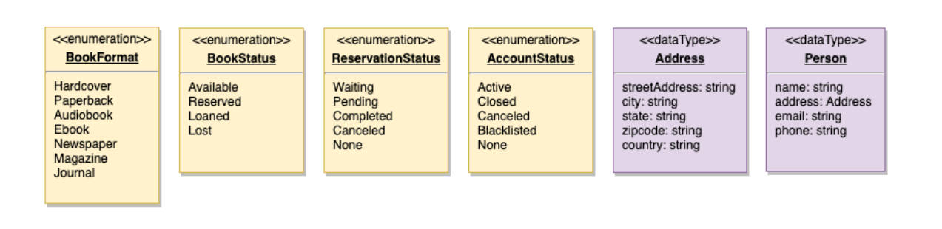

# **Process Flow/Representation**

* 1. **Activity Diagram**

**Check-Out A Book:** Any library member or librarian can perform this activity. Here are the set of steps to check-out a book.

**Return A Book:** Any library member or librarian can perform this activity. The system will collect fines from members if they return books after the due date. Here are the steps for returning a book.

**Renew A Book:** While renewing (re-issuing) a book, the system will check for fines and see if any other member has not reserved the same book, in that case the book item cannot be renewed. Here are the different steps for renewing a book.

**Issue A Book:** The librarian will issue the requested book asked by the user. While issuing the new book the librarian will check the limit of the books issued. The steps to issue book are as following:

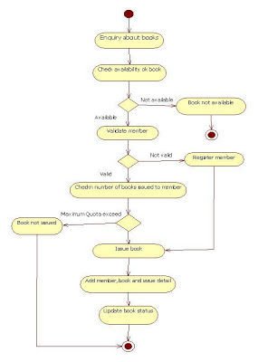

# **Design Models**

The applicable models may include:

* 1. **Class Diagram**

* 1. **Sequence Diagram**

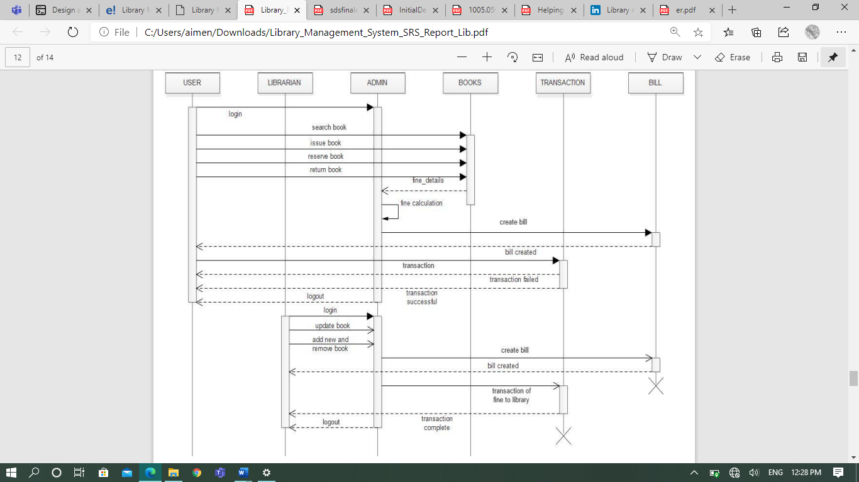

**Returning Book:**

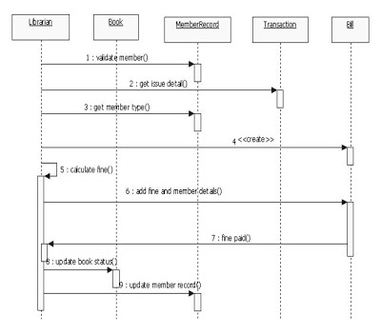

**Issuing Book:**

* 1. **State Transition Diagram**

**Book:**

**Librarian:**

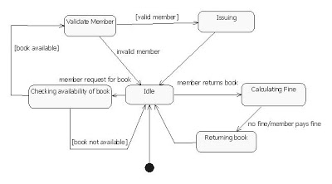

* 1. **Context Level Diagram**

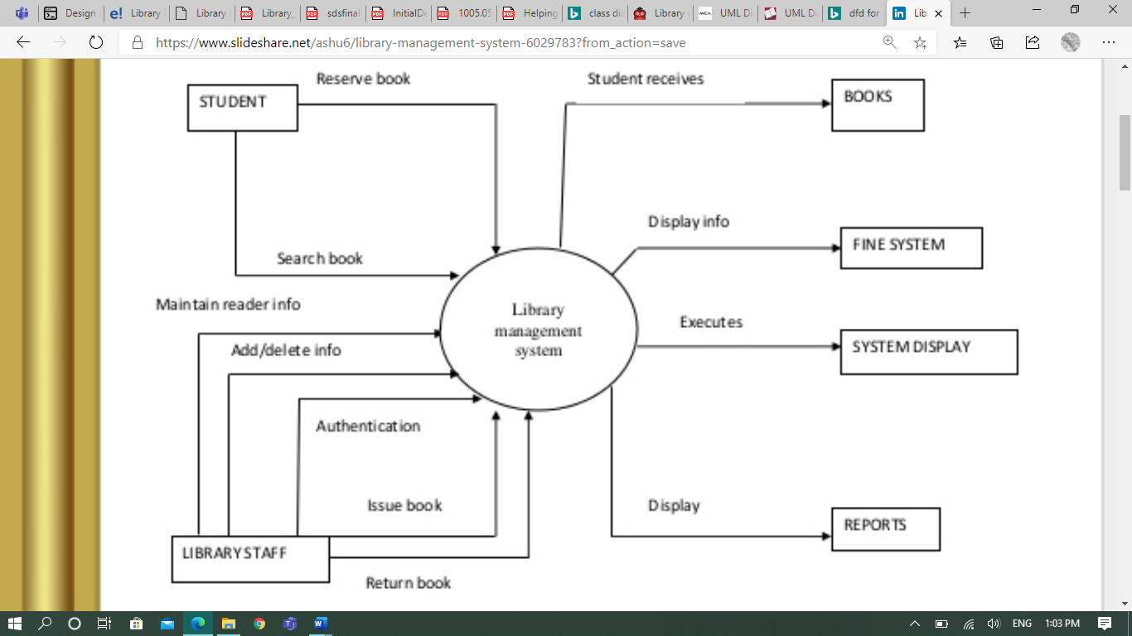

* 1. **Use Case Diagram**

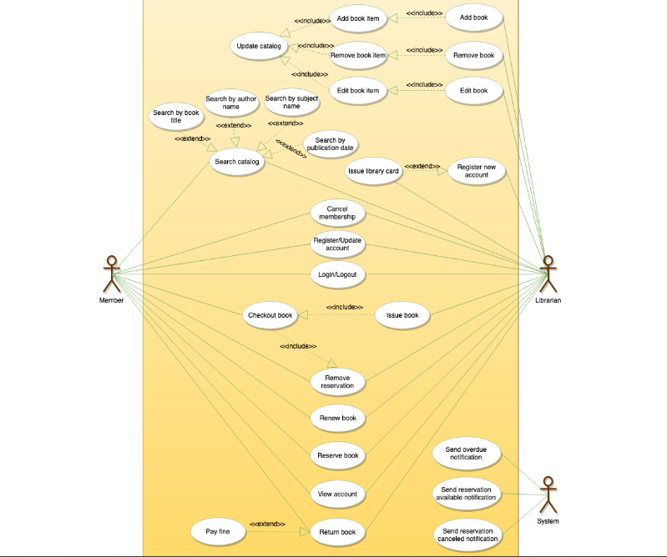

* 1. **Data Flow Diagram**

**LEVEL 0:**

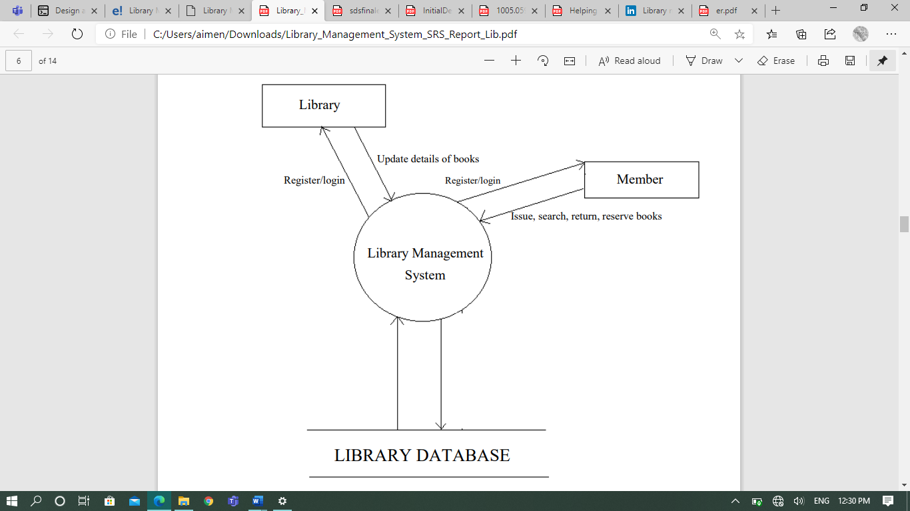

**LEVEL 1:**

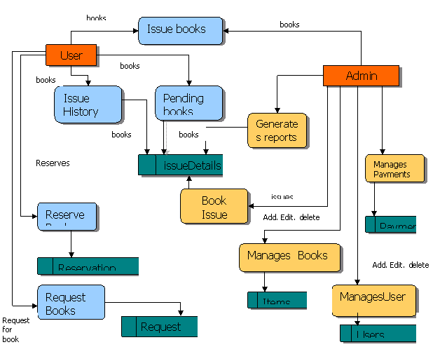

**LEVEL 2:**

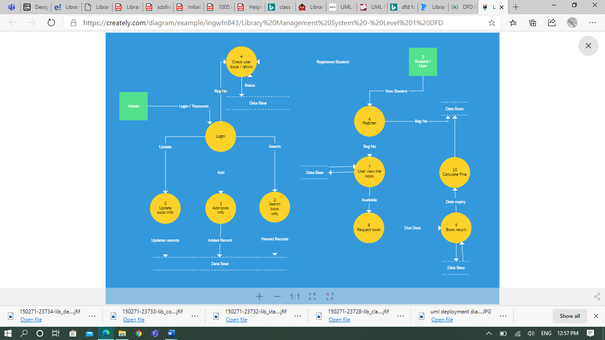

**LEVEL 3:**

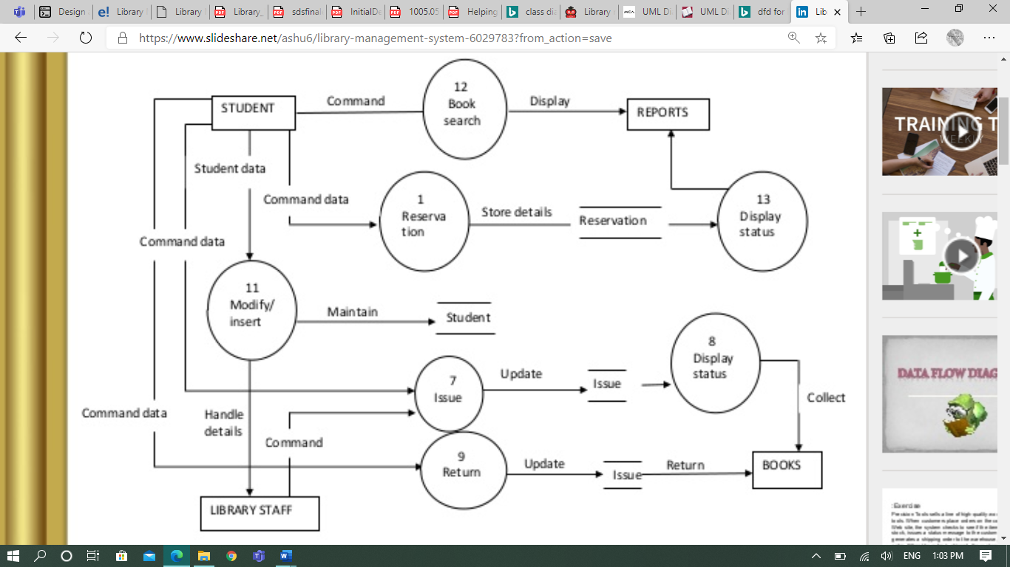

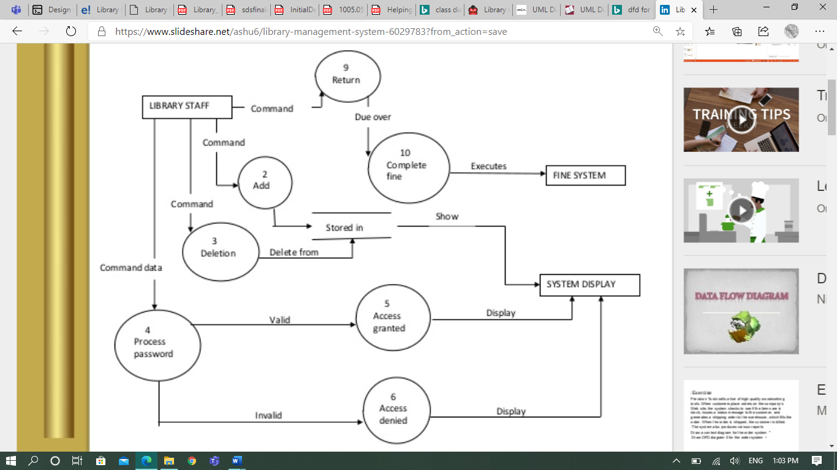

# **Algorithm & Implementation**

The major features algorithm of Library Management System is mentioned below:

**Login:**

Get Username and Password. If username is equal to the entered Username & the password is equal to the entered Password. Then login successful. Else login failed. End If.

Get Username Get Password

IF FILE EXIST THEN

READ Password FROM FILE

IF FILE. Password == Entered Password

Login successful

ELSE

PRINT “incorrect Username or password “

END IF

ELSE

PRINT “incorrect Username or password “

END IF

**User - Edit Profile:**

User login to account

Select user personal details option

While Edit Profile {

Add details

Remove details }

Save changes

EXIT

**New User Registration:**

To add a user, the user will click on the button “Add User” and mention details such as username, email, password and choose the radio button user or admin. By default, it will be the user. By the name and email the system will validate that whether this is an existing user or a new user. If the user is an existing one a dialog box will appear that says “Existing User… Please login!”. If the user is not existing, it will enable the create button. Then, click on Create button. The user is created, now, if you click on View Users button, you will see the user added in the database.

**Book Search:**

The user will click on Search Book button, then the book search page appears. The user can search the book through author, subject, and name category. The user will select any one of the categories and then will enter the name, subject or author and then click on search button. All possible results will be displayed after that and user can select the desired book.

**Book Issue:**

The user will click on the Issue Book button, then book issue page appears, first will check that whether the user can issue the book or has already issued the maximum number of books. If the user has reached maximum number of books limit, a message box will appear which says “you cannot issue more books” but if the user is within range the user will mention the Book ID, User ID, Period (Number of days for issuing the book), and the Issue Date. Then click on Submit button. The book is issued.

**Book Return:**

To return the book user will click on Return Book button. Return book page appears. User mention the Book ID, Issue ID, and the return date of the book. Then click on Return button. Then, system checks whether the book has been returned in the valid time period or has crossed the due date. If the book has crossed the due date, the system will calculate the number of days above due date and will charge fine accordingly and a message box displaying the fine appears. A subsection activates were the user is supposed to enter the credit card credentials and then click on pay fine button. After that, a dialog box, showing the message “Book Returned “appears. Now, if the user clicks on the View Issued Books, user will see the issued books do not have that returned book.

**Update Book Details:**

When the Update Book Details button is clicked the system checks whether its admin or user, if user the system disable the button but if an admin the button to proceed further is enabled. The admin search for the book to be update in the search box and then click on it. Details of that book appears; admin click on enable edit button and then edit the details. After done with editing the admin click on Update button and a message box appears that shows Details Updated! Message.

**Fine Payment:**

When the user returns a book in return book section, before returning the book the system checks for the due date. If crossed, the system calculates the days above the due date. Then multiply the number of days above due date with 15 Rs/- per day. The total amount is then mentioned in a dialog box. Here, returns button is disabled automatically until the fine is payed. The fine payment section is enabled and asks for Name and Card Number. Then the user clicks on pay fine button. If the fine is payed through the card, a message box for fine payed appears and the return book button is enabled. But if the card is not valid, or do not have enough amount a dialog box for invalid card number or insufficient money appears. And asks to enter a valid one. After the fine is payed.

# **Appendix I**

1. **How to design using UML (OOP):**

For guidance please follow the instructions mentioned in the link below: http://agilemodeling.com/artifacts/

1. **How and when to design ER diagrams:**

For guidance please follow the instructions mentioned in the link: <http://people.inf.elte.hu/nikovits/DB2/Ullman_The_Complete_Book.pdf>

1. **Data flow diagrams:**

<http://www.agilemodeling.com/artifacts/dataFlowDiagram.htm>

Software Engineering –A Practitioner’s approach by Roger Pressman